DATASET:
Two biomedical resources were utilized to construct a unified clinical knowledge graph that integrates ontology:
- SNOMED CT (U.S. Edition 2025-03-01 Snapshot):
- A large-scale clinical terminology containing over 350,000 concepts and more than 3.5 million relationships.
- SNOMED CT provides structured definitions of diseases, findings, and procedures using relationship types such as is_a, part_of, associated_with, and morphology_of.
- MIMIC-IV (Version 3.1):
- An open critical-care database that includes de-identified electronic health records from 40,000+ ICU patients.
Integrating these two resources enables the combination of semantic hierarchy from SNOMED CT with empirical diagnostic co-occurrence patterns from MIMIC-IV, forming the basis for multi-relational graph learning.
SNOMED CT Relation and Description Extraction:
The SNOMED CT release contains two main components essential for semantic graph construction:
- Relationship Table (sct2_Relationship_Snapshot) Each record defines a directed relation between a source concept and destination concept, encoded as {sourceId, typeId, destinationId} with flags for activity status and relationship group.
- Description Table (sct2_Description_Snapshot) Its table provides textual labels for each concept, including fully specified names, preferred terms, and synonyms.

Preprocessing Steps
The dataset was cleaned and standardized using our SNOMED preprocessing script, which performs:
- Filtering to retain only active relationships (active = 1).
- Selecting preferred terms using the identifier typeId = 900000000000013009
- Mapping each relation type ID to a human-readable relation labe (e.g., 116680003 → is_a, 47429007 → associated_with).
- Removing null, incomplete, or corrupted rows.
- Logging before/after counts to ensure reproducibility.
Output:
The final SNOMED relation dataset (snomed_relations_full.tsv) contains:
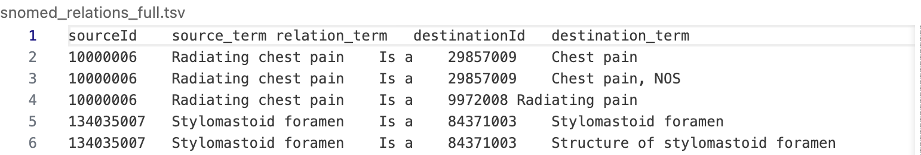
Why This Extraction Was Necessary
- Provided structured semantic relationships for graph construction.
- Ensured readable, interpretable edge labels for downstream analysis.
- Served as the ontology backbone to which empirical relations (from MIMIC-IV) could be later attached.
MIMIC-IV ICD to SNOMED CT Mapping via OHDSI Athena:
- The hosp/diagnoses_icd.csv.gz table was used to extract structured diagnosis information encoded in ICD-9-CM and ICD-10-CM formats.
- For consistency with current SNOMED CT coverage, only ICD-10-CM codes were selected for the study
- The diagnoses in MIMIC-IV are represented using ICD-10 codes, which are optimized for billing and reporting rather than semantic reasoning.
- To align these codes with SNOMED CT’s concept hierarchy, a standardized, curated mapping approach was required.
- I used the OHDSI Athena vocabulary repository, which provides official vocabularies, to perform ICD-10 → SNOMED CT translation.
Reasons for choosing OHDSI Athena:
- Curated “Maps to” relationships: Maintains official ICD↔SNOMED links with clinical equivalence defined by domain experts.
- Regularly updated: Synchronizes with Unified Medical Language System (UMLS) and SNOMED CT releases, avoiding outdated code mappings.
Data Extracted from Athena:
The following two core vocabulary tables were used:
- CONCEPT.csv – defines every concept’s name, ID, vocabulary source (ICD10CM, SNOMED), and domain.
- CONCEPT_RELATIONSHIP.csv – defines relationships between concepts (e.g., Maps to, Maps to value).
Mapping Methodology: The mapping process was:
- Loaded CONCEPT.csv and CONCEPT_RELATIONSHIP.csv.
- Extracted relations labeled: Maps to and Maps to value"
- Filtered for mappings where:
  - Source vocabulary = {ICD10CM}
  - Target vocabulary = SNOMED
- Joined textual concept names for interpretability.
- Merged these mappings with MIMIC diagnosis records.
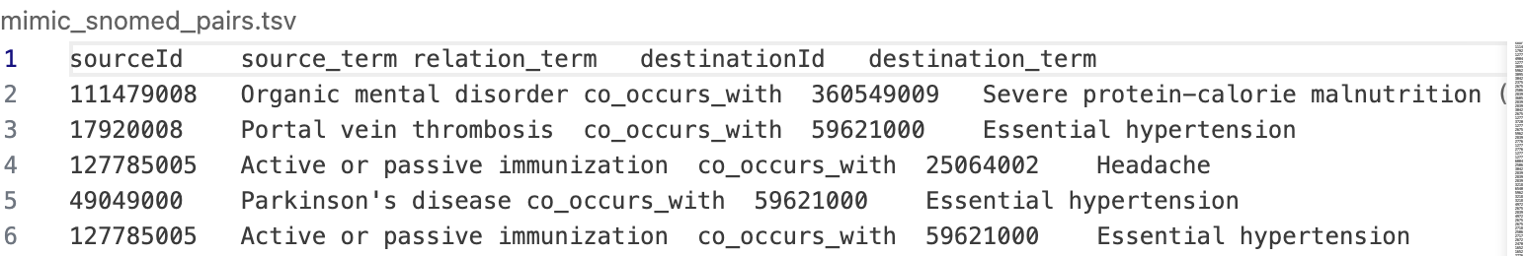
How the Mapping Helped:
- Bridged the semantic gap between administrative ICD coding and ontology-based SNOMED terminology.
- Enabled the transformation of numeric ICD codes into SNOMED CT identifiers that could directly connect with the ontology’s relational network.
- Created a semantically unified schema, allowing MIMIC data to participate in SNOMED’s hierarchical and associative relations.

SNOMED CT and MIMIC-IV Multi-Relational Graph Construction
After both datasets were standardized to SNOMED CT identifiers, a unified multi-relational graph was constructed.
Step 1: MIMIC Co-Occurrence Graph Generation
For each hospital admission (hadm_id), all unique SNOMED-mapped diagnoses were paired to form co-occurrence relations, represented as:
source_term | relation_term | destination_term | relation_term = "co_occurs_with"
Each edge indicates that two diagnoses co-appeared in a patient record.
Step 2: SNOMED Ontology Graph
From SNOMED CT, relationships such as is_a, part_of, associated_with, and morphology_of formed the ontology edges, representing formally curated medical knowledge.
Step 3: Merging Both Graphs
The ontology-based and co-occurrence-based relations were concatenated into a single dataset:
sourceId | source_term | relation_term | destinationId | destination_term | source
where:
- source = SNOMED_CT → denotes curated ontology relations
- source = MIMIC_IV → denotes empirical co-occurrence relations
The final graph, merged_relations.tsv, integrates both ontology-defined and empirical co-occurrence relations, providing a rich, heterogeneous structure suitable for Relational Graph Convolutional Network (RGCN) training.
Sample of Final dataset:
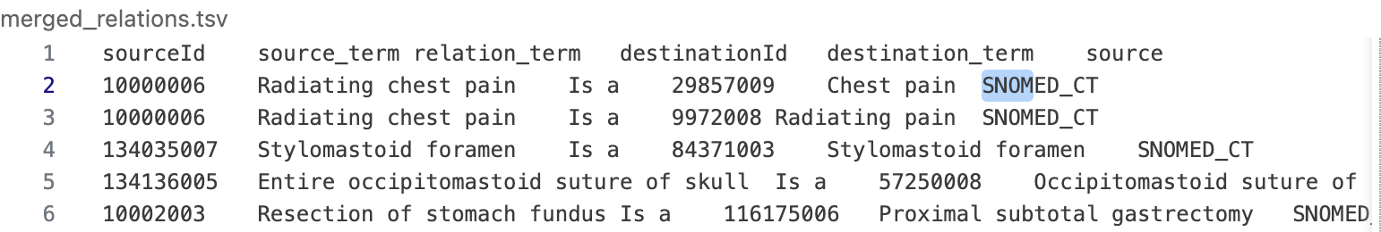
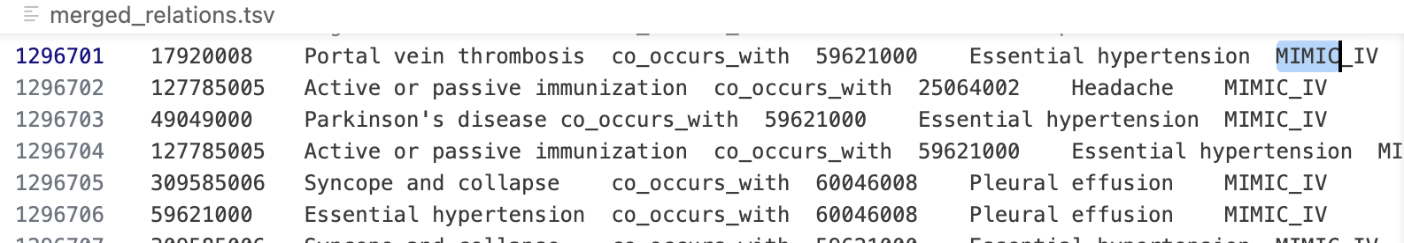

Conflict Detection and Quality Assurance
We detected and resolved inconsistencies in the merged dataset.

Identified Conflicts
- Same concept pair linked by different relationship types.
- Multiple ICD-10 codes mapping to the same SNOMED concept.
- Duplicate or redundant edges.
- Missing concept descriptions.
MODEL DEVELOPMENT REPORT
Fixed Embedding Size Problem
Previous models use:
- ONE single embedding dimension for ALL nodes
- Regardless of node importance (degree) or graph connectivit

SOLUTION— Dynamic-Capacity Embedding (Largest Contribution)
Instead of one fixed-size embedding, your model:

High-degree nodes → 512-dim embeddings

Low-degree nodes → 128-dim embeddings
Then both are projected into: 256-dim shared GNN space
This means:
- Important clinical concepts get more representational power
- Rare concepts get compact & efficient embeddings
- R-GCN operates on a balanced space
This is the first scalable SNOMED-CT/MIMIC R-GCN design with degree-aware dynamic capacity.

Scalability Problem
Past work trains on: Only SNOMED internal hierarchy or small toy graphs
But integrated dataset has:
- 369,354 nodes
- 2.39 million edges
- 202 relation types
A full-graph R-GCN on this size is:
- Too slow
- Too memory-heavy
- Impossible to run on Google Colab + Mac

SOLUTION— Pure-PyTorch Multi-Hop Neighbor Sampling
Instead of training on the entire graph, you implemented:
- 2-hop neighbor sampling
- 10 neighbors per hop
- Sampling subgraph for each mini-batch
This allows:
- Scaling to 2.4 million edges
- Training on Kaggle GPU P100
- No dependency installation
- No memory overflow
This solves scalability in a way that previous papers never attempted.
Graph Data.pt contains:
Key | Meaning
num_nodes | Total 369,354 nodes
num_relations | 202 SNOMED/MIMIC relation types
edge_index | Shape: [2, 2,392,096] → source + destination
edge_type | Relation type for each edge

Why loading takes long:
- File size is large
- torch.load() decompresses tensors
- Moving 2.39M edges to GPU
- Degree calculation scans all 2.39M edges
- Building adjacency list for neighbor sampler → loops through every edge
This is normal and unavoidable for large graphs.
Design uses:
- Pure Python adjacency lists
- Python for-loops
- Dynamic sampling
- 4096 edges per batch
- Heavy R-GCN matrix multiplications
- 2.39 million edges total

Runtime comes from:
- Sampling subgraph every batch
(Pure Python loops → slow but memory safe)
- Dynamic-capacity embedding mapping
(lookup dictionaries + tensor projection per batch)
- Building local R-GCN graph for each batch
- Running 5 epochs × ~90k batches

What Can Reduce Training Time (But May Affect Research Idea)
Change | Effect on Time | Effect on Accuracy / Research Integrity
Reduce neighbors from 10 → 5 | 30–40% faster | Weaker neighborhood → hurts scalability
Reduce EMB_HIGH from 512 → 256 | 20% faster | Weakens embedding size idea
Use 1-hop instead of 2-hop | 40–60% faster | Missing clinical structure
Use basis-decomposition R-GCN | Faster | But less expressive
Reduce batch size | Faster | Very unstable ranking loss

Epoch Loss Interpretation
Your results: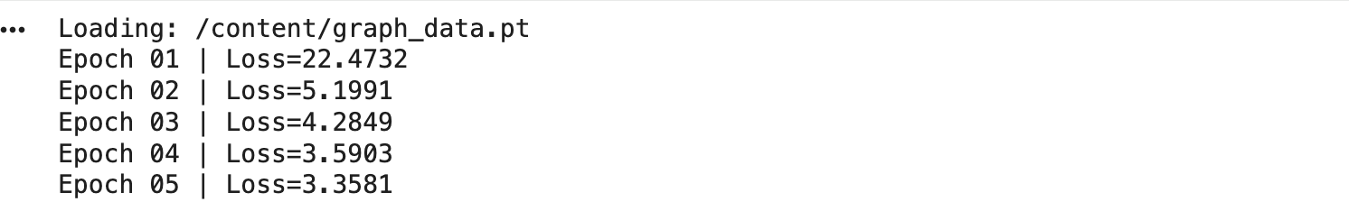
- Loss is decreasing → model is learning
- Large drop from Epoch 1 → 2 → embedding is stabilizing
- Smaller drops afterward → model converging
Since R-GCN uses margin ranking loss, accuracy ≠ simple metric.
But lower loss = better ability to:
- Rank true tail/head above negative samples
- Predict correct SNOMED relations
- Improve link prediction

Pseudo code
Train Dynamic R-GCN with embedding size and scalability
Input:
G = (V, E, R) // graph nodes, edges, relations
D = {train_idx} // training triples
H = {512,128} // high/low embedding dimensions
K = neighbors per hop
L = number of GNN layers (2)
EPOCHS = total epochs
Begin
-------------------------------------------------------
1. Compute degree for every node in V
2. Split nodes:
HighDeg ← nodes with degree ≥ percentile(80)
LowDeg ← all other nodes
3. Initialize DynamicEmbedder:
emb_high: |HighDeg| × 512
emb_low : |LowDeg| × 128
project both → 256-dim space
4. Build adjacency list:
for each edge (u, r, v):
adj[r][u].append(v)
Training Loop:
for epoch = 1 to EPOCHS do
shuffle(train_idx)
for each batch B in train_idx do
// --- Positive & Negative Sampling ---
pos = edges[B]
neg = corrupt_tail(pos)
// --- Seed Set for Subgraph ---
seeds = unique({pos.h, pos.t, neg.h, neg.t})
// --- GAP-2: Multi-hop Sampling ---
S ← seeds
for l = 1 to L do
S ← S ∪ sample K neighbors of each node in S
// Build local subgraph
local_nodes ← sorted(S)
local_edges ← edges connecting nodes inside S
// --- R-GCN Forward ---
X ← embeddings(local_nodes)
for each layer i:
X ← RGCNLayer_i(X, local_edges)
// --- Compute Scores ---
pos_score = score(pos)
neg_score = score(neg)
// --- Update ---
loss = margin_ranking_loss(pos_score, neg_score)
backprop(loss)
end for
save_checkpoint(epoch)
end for
save_final_model()
Return trained model

Next Steps

Re-run training once more & SAVE MODEL every epoch
- You already implemented:
- ✔ checkpoint saving
✔ final model saving

Generate Node Embeddings (.npy)
After saving model, compute:
node_embeddings_pure_gap1_gap2.npy
These embeddings are used for:
- SNOMED relation prediction
- Graph analytics
- Downstream classifiers
- Visualizations

Evaluate link prediction
Compute:
- MRR(Mean Reciprocal Rank)
- Hits@1
- Hits@3
- Hits@10

